Smart eDNA sampling strategies: Species spatial autocorrelation can guide efficient marine survey design

Gledis Guri¹, Ryan Kelly¹, Ole Shelton², Krista M. Nichols² (any other who should be included)

Introduction
Sampling efficiency is the perfect balance between having the least number of samples for the highest reward in information. You don’t want to have multiple samples that are giving the exact same information while you also don’t want to have too few samples that are not being able to give the information.

Marine sampling efficiency plays a critical role in collecting sufficient and representative samples to accurately assess species distributions, forming the foundation for sound fisheries management and stock assessment protocols. In stock assessment contexts, determining the appropriate sample size is vital for reliable estimation of population parameters including abundance, demographic structure, and spatial distribution patterns. This process must balance the need for sufficient data for detecting trends and changes in population while also ensuring that incurring unnecessary costs or effort are minimized. Excessive sampling can lead to redundant data -- multiple samples that gives the exact same information – whereas insufficient sampling risks overlooking critical patterns and producing unreliable estimates. Identifying the point at which sampling efficiency is optimized is crucial therefore, efficient sampling strategies are designed to capture the spatial variability of marine communities, allowing researchers to infer ecological traits such as habitat preferences and ecological niches without making a big dent on the budget.

there is a need for determining where the sampling efficiency is optimal. Therefore, efficient sampling strategies are designed to capture the spatial variability of marine communities, allowing researchers to infer important ecological traits such as habitat preferences and ecological niches.

Identifying the point at which sampling efficiency is optimized is therefore crucial therefore, efficient sampling strategies are designed to capture the spatial variability of marine communities, allowing researchers to infer ecological traits such as habitat preferences and ecological niches without making a big dent on the budget.

Efficient sampling strategies aim to capture the spatial variability of marine communities, enabling researchers to infer critical ecological traits such as habitat preferences and species’ ecological niches.

While increased sampling intensity generally reduces variance in population estimates and improves the precision of spatial pattern detection, this relationship exhibits diminishing returns where beyond a certain threshold, additional sampling effort produces marginal gains in statistical precision that may not justify the associated costs and logistical demands. The optimal sampling intensity occurs at the point where incremental improvements in precision or information content become disproportionately small relative to the required investment of resources and effort. This principle guides the development of cost-effective sampling strategies that maximize analytical power while minimizing operational expenditure.

The emergence of environmental DNA (eDNA) sampling has revolutionized marine monitoring capabilities, offering a non-invasive method to detect species presence and estimate relative abundance. However, eDNA introduces unique considerations for sampling design. Unlike traditional methods where detection occurs at the point of sampling, eDNA signals integrate information from surrounding areas through processes of DNA transport and decay. This spatial integration effect means that adjacent eDNA samples may contain overlapping information, making the question of optimal spatial sampling resolution even more critical.

In many inferences of species distribution, habitat preferences and population estimates, statistical models such as Gaussian Processes (GP) are typically used to explain and understand the predictive patters of fish aggregations, population estimates, and dispersal across space. [give some examples]. The foundation of this approach rests on the assumption that species distributions in nature follow patterns that can be effectively modeled using Gaussian Processes (GPs). This mathematical framework captures an essential ecological principle: species tend to form one or more areas of high concentration - "hotspots" - where individuals aggregate densely. As distance increases from these central areas, population density gradually declines in a smooth, continuous manner. The distribution of a species at various locations can be expressed as:
$$Y_{i} \sim MVN(μ_{i},k(x,x'))$$
$$k(x,x')=α^{2}*exp⁡\left(-\frac{1}{2ρ^{2}}*{\left\|x-x'\right\|}^{2}\right)+σ^{2}$$
where Y is the observed abundance or density of the species at location i with a mean abundance μ and covariate matrix k of coordinate x and x’. The covariate matrix is the most important part of the Gaussian Process (GP) as it determines the spatial autocorrelation of the species distribution where α is the amplitude of the x-x’ correlation, ρ is the length-scale parameter meaning the correlation (in x-x’ units) where the signal fades out, and σ is the noise in nature. Species with small spatial autocorrelation (ρ) values exhibit rapidly changing abundance patterns over space, indicating highly localized distributions with sharp boundaries between high and low-density areas. Conversely, species with large ρ values display smoothly varying abundances that remain spatially autocorrelated over greater distances, suggesting more gradual transitions and broader distribution patterns.

In simple terms, knowing the spatial autocorrelation of species distributions can provide a quantitative basis for optimizing sampling effort - species exhibiting high spatial autocorrelation should require fewer samples to capture their distribution patterns due to their extended spatial coherence.

Here we investigate the relationship between species-specific precision of abundance estimate inferred from GP models under varying sampling efforts and the spatial autocorrelation parameter. Due to the spatiotemporal integration in eDNA signals – DNA signal from organisms located at varying distances from the sampling site and at different time points prior to collection - an additional layer of spatial autocorrelation is introduced beyond what would be expected from species distribution patterns alone. Consequently, when applying Gaussian Process models to eDNA data, the spatial autocorrelation parameter inherently captures both the natural clustering patterns of species distributions and the physical processes that govern DNA dispersal and decay in the marine environment. Without concurrent independent sampling methods such as trawl surveys or acoustic monitoring to provide direct measures of local abundance, these two fundamental processes - biological smoothness and spatiotemporal eDNA integration - cannot be empirically separated and are therefore represented as a single integrated parameter within the modeling framework.

Here we investigate the accuracy and estimate

Methods

Sample Collection

Metabarcoding

Simulated eDNA data

Statistical inference
Here we used both simulated (Gaussian Process parameters) and real-world eDNA concentration data (unknown Gaussian Process parameters) to evaluate the impact of sampling effort on spatial field prediction accuracy. For each dataset, we first fitted Gaussian Process models to estimate the GP parameters and predict eDNA concentration across the spatial field. We then systematically reduced sample sizes by randomly removing 10%, 20%, 30%, 40%, and 50% of the original sampling points and re-fitted the Gaussian Process models to these reduced datasets. To quantify the accuracy of Gaussian Process predictions for each sampling effort, we calculated the mean prediction error (ε) as the difference between the spatial fields predicted from the complete dataset and those predicted from each reduced sampling scenario. We iterated this process 200 times to get better estimates.

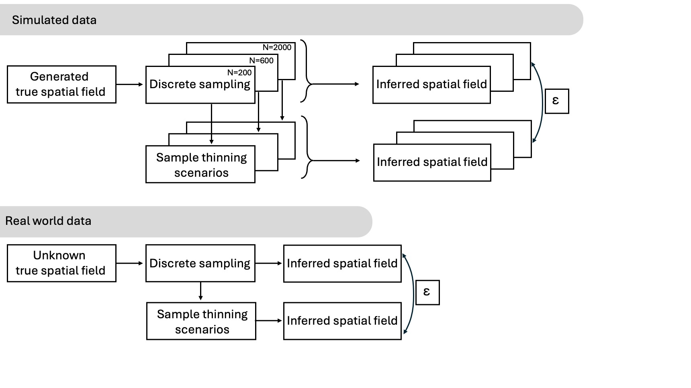

2 types, ecological parameters and predictive precision.

Results

Figure 2
